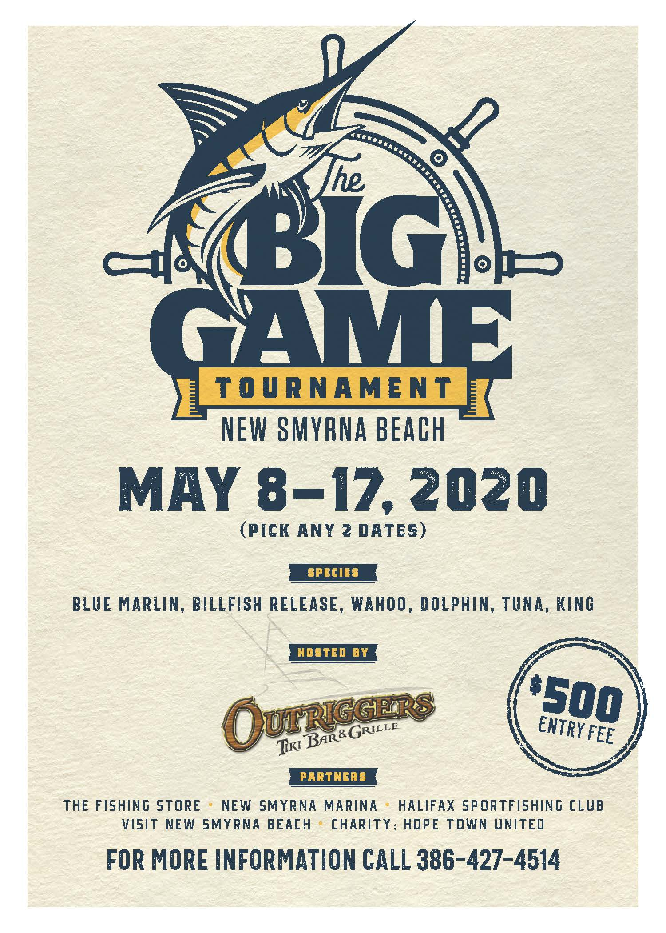
New Smyrna Beach Big Game Tournament

2020 Sponsorship Package

Sponsor: ____________________________________________

Contact: _____________________________________________

Proposal Date: ___________________________________________________

Phone #: __________________________________________________________

Business Address: _______________________________________________

Package Selection (Mark Selection)

_____ Title Sponsor- ($10,000) (1)

_____ Presenting Sponsor- ($5,000) (6)

______ Platinum Sponsor-($1,000) (6)

_______ Diamond Sponsor-($500) (10)

_______ Gold Sponsor- ($250) (20)

Sponsor Graphics: Yes____ No _____ (JPG, EPS, PDF, AL)

(Please email graphics asap to thefishingstore@gmail.com)

Sponsor Signature: _____________________________________________________________________

Total Amount:__________________________ Due Date: ____________________________

Make checks Payable to: NSBBGT

We Happily announce a portion of the proceeds to benefit
Hope Town United.
(In Lew of our efforts to aid in hurricane Dorian relief)

Mailing Address: 200 Boatyard st. New Smyrna Beach FL. 32169
FACEBOOK: New Smyrna Beach Big Game Tournament

